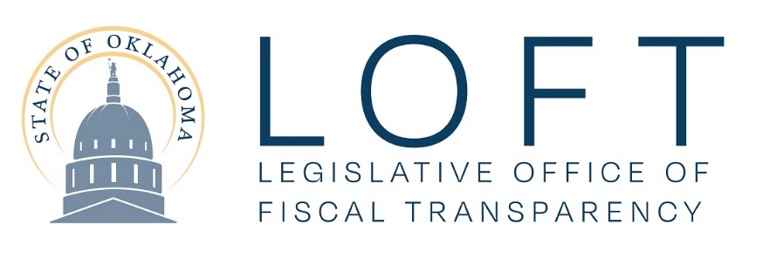
Position Announcement
Opening for
Economist

Overview
The Legislative Office of Fiscal Transparency (LOFT) provides comprehensive, non-partisan fiscal and program analysis for the Oklahoma State Legislature. LOFT is seeking an Economist to provide expertise to accomplish the organization’s mission. Individuals who have a Bachelor's or Master's degree in Economics, Public Policy Analysis, Public Administration, Business Administration or a related field are encouraged to apply for this opportunity.

A description of the Economist position follows. We offer competitive salary and benefits.

Applicants should send an electronic letter of introduction with a resume to mike.jackson@okloft.gov. Applications will be reviewed in the order received and the application period will remain open until the position is filled.

Characteristics of the Position
LOFT is a state agency in the legislative branch that assists the Oklahoma House and Senate. LOFT provides budgetary recommendations to the LOFT Oversight Committee for use in setting the funding of state government, higher education, and public schools. LOFT is charged with ensuring state agency programs are efficient, effective and transparent. The LOFT Oversight Committee includes seven senators and seven representatives with political parties represented in proportion to membership in each house of the legislature.

Primary Responsibilities:
- Provide revenue forecasting, tax analysis and economic analysis related to specific state revenue sources.
- Coordinate periodic forecasts of state revenue along with explanatory materials.
- Monitor revenue collections to be included as part of a monthly publication to the Legislature on the status of the forecast.
- Analyze tax and economic issues for the Legislature.
- Maintain knowledge and expertise related to current state of the Oklahoma and national economies with emphasis on potential impacts on Oklahoma revenue collections.
- Provide staff support, including testimony, to the members of the Oklahoma House of Representatives and the Oklahoma Senate in their development of tax legislation and policy matters.
While economists work independently on individual revenue categories, they also collaborate in a fast-paced, team environment in developing the overall state revenue forecast and other relevant economic reports and data.

Minimum Qualifications
• Master's or Bachelor’s degree in Economics, Public Policy Analysis, Public Administration, Business
Administration or a related field for an economist position. Relative work experience may
substitute for a graduate degree.
• Expertise to provide accurate forecasts of state revenues, using economics,
econometrics and statistics.
• Experience in interpreting financial and economic data
• Exceptional written and verbal communication skills

More Information
You can find more information on LOFT Careers @ http://www.oklegislature.gov/.

